Matshidiso Nthebe
ST10449727
POE PART 1 PROGRAMMING 2B
PROGECT PLAN FOR A POE
project plan
CMCS

Table of Contents
Project Plan: Contract Monthly Claim System (CMCS) 1
1. Project Overview 1
2. Purpose 1
3. Stakeholders & User Roles 1
4. Objectives 2
5. System Workflow 2
6. Requirements 2
Functional Requirements 2
Non-Functional Requirements 3
7. Project Deliverables 3
8. Technology Stack 3
9. Project Timeline (8 Weeks) 4
10. Risk Management 5
Entity Diagram: 6
11. Success Criteria 6

Project Plan: Contract Monthly Claim System (CMCS)

1. Project Overview
The Contract Monthly Claim System (CMCS) is a web-based platform developed in ASP.NET (C#). It is designed to allow Independent Contractor (IC) lecturers to submit their monthly claims online. The goal is to replace the current paper-based process with a digital solution that provides efficiency, transparency, and a clear approval workflow involving Programme Coordinators and Programme Managers.

Purpose:
- Streamline and digitalize the lecturer claim submission process.
- Minimize delays, errors, and inefficiencies associated with manual record keeping.
- Provide transparent approval workflows with timestamps and accountability.
- Allow users to upload supporting documents to strengthen claim validation.

3. Stakeholders & User Roles
- Users:
- Lecturer:
  - Registers, log in, submit claims, and uploads documents.
  - Tracks claim status.
- Program Coordinator:
- Reviews and validates lecturer claims.
- Approves or rejects claims.
- Program Manager (PM):
  - Conducts final approval/rejection.
  - Provides final claim status (Finalized/Rejected By PM).
- Stakeholders:
  - Students (Developers)
  - Academic staff (End users)
  - Module Coordinator (Supervisor)

4. Objectives
- Develop a secure, user-friendly claim management platform.
- Implement structured approval workflows.
- Ensure data integrity with a well-structured database.
- Provide auditability via timestamps and status tracking.

5. System Workflow
- Lecturer registers and logs in.
- Lecturer submits claim with details (hours, rate, total, documents).
- Claim status = Pending with timestamp.
- Program Coordinator reviews:
  - Approve → status = Approved
  - Reject → status = Rejected
- Program Manager reviews:
  - Approve → status = Finalized
  - Reject → status = Rejected By PM
- All claim activities tracked with timestamps and user history.

6. Requirements

Functional Requirements
- User Management
  - Registration
  - Login/Logout
  - Role-based access control
- Claim Management
  - Submit claim form
  - Upload supporting documents
  - View claim history & status
- Approval Process
  - Coordinator review dashboard
  - PM finalization dashboard
  - Approve/Reject actions with comments
- Tracking & Reporting
  - Claim status history with timestamps
  - View claims per lecturer/module/month

Non-Functional Requirements
- Security: Role-based authentication & authorization.
- Usability: Intuitive GUI, error handling, form validations.
- Scalability: Modular structure for future features.
- Performance: Efficient database queries, minimal latency.

7. Project Deliverables
- Database schema (SQL Server)
- .NET Web App (C#) with GUI
- Functional pages: Register, Login, Submit Claim, Track Claim, Coordinator Approval, PM Finalization
- Documentation: User Manual, Technical Report

8. Technology Stack
- Framework: ASP.NET Core (.NET 6 or 7)
- Language: C#
- Database: SQL Server
- UI: Razor Pages / Blazor (optional MVC)
- Authentication: ASP.NET Identity
- Version Control: Git/GitHub

9. Project Timeline (8 Weeks)
Week | Task | Deliverables
1 | Project setup, requirements gathering | Project Charter, Requirements Spec
2 | Database design & ERD | Database schema
3 | User authentication (Register/Login) | Functional login/register
4 | Claim submission module | Claim form with uploads
5 | Approval workflows (Coordinator, PM) | Approval dashboard
6 | Claim tracking + history | Claim status pages
7 | Testing (Unit & Integration) | Test results
8 | Final deployment + documentation | Working system + PoE

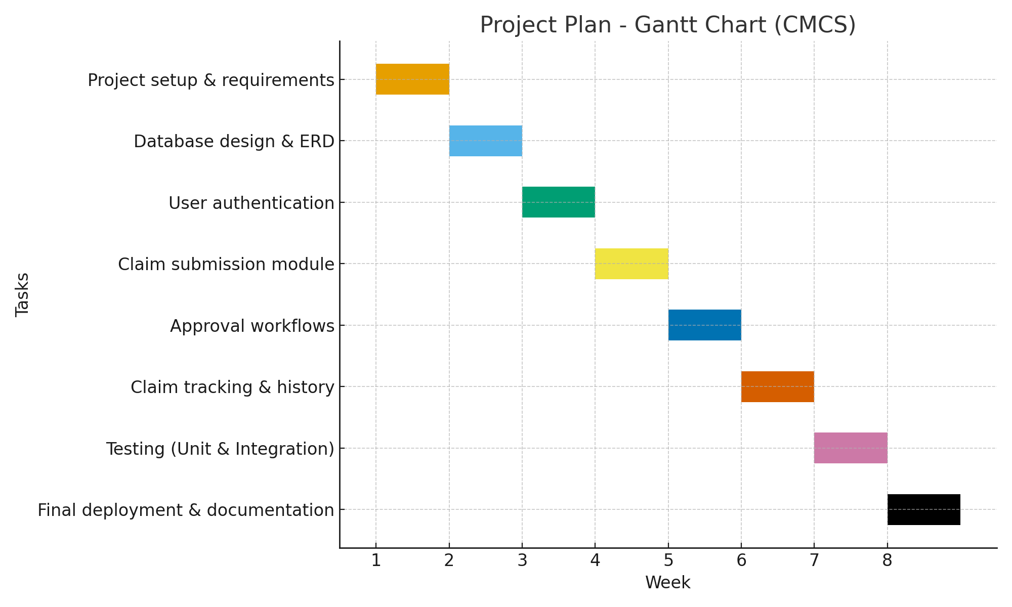

10. Risk Management
Risk | Impact | Mitigation
Lack of .NET knowledge | High | Research, tutorials, discussions
Database errors | High | Backup strategy, test queries
Delays in progress | Medium | Weekly plan, version control
Security vulnerabilities | High | Validation, role-based access control

Entity Diagram:
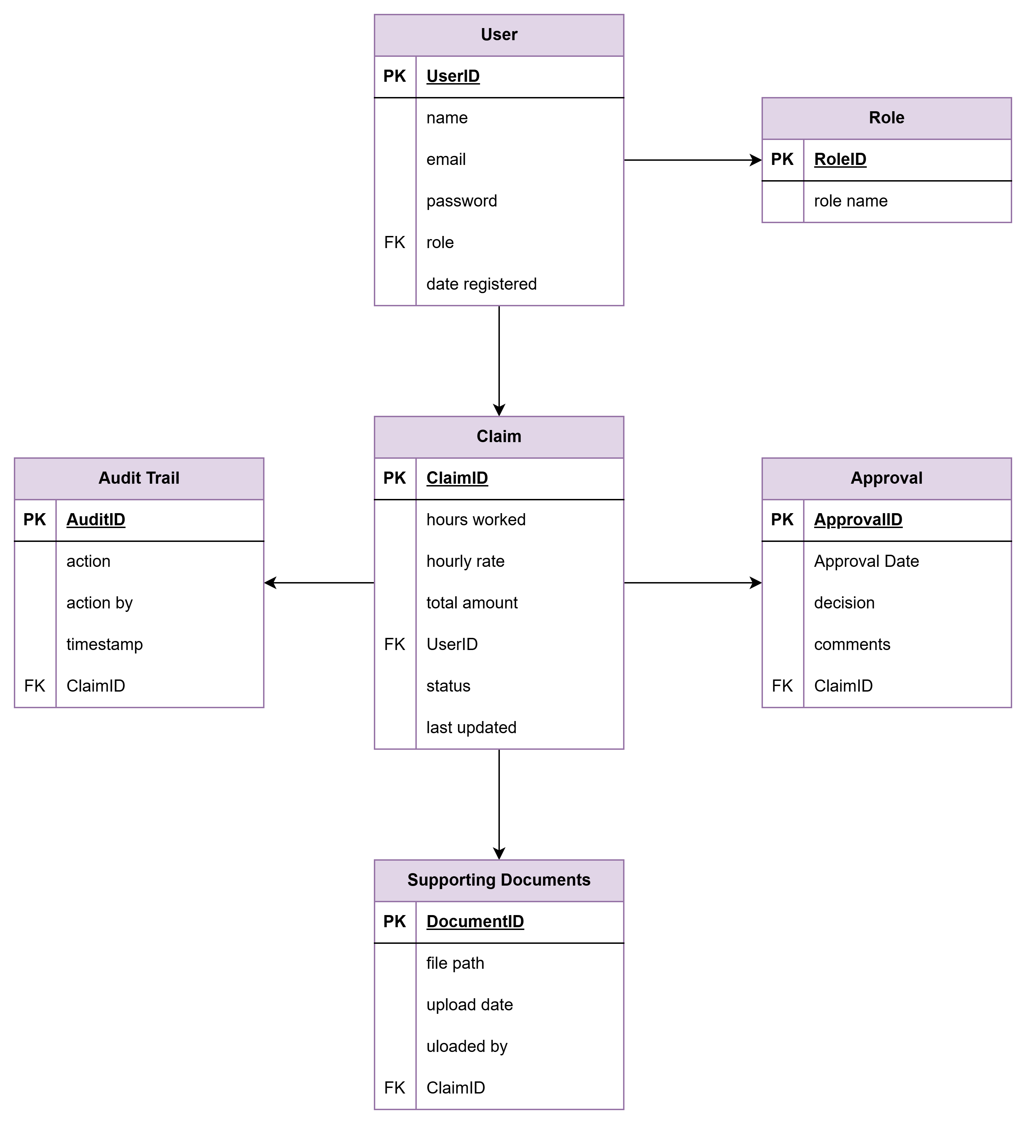

11. Success Criteria
- Fully functional CMCS with working claim submission and approval workflows.
- Secure login with role-based permissions.
- Accurate claim calculations and history tracking.
- Positive user experience (simple and intuitive GUI).

Reference List:
- Microsoft. (2023). ASP.NET Core Documentation. Retrieved from https://learn.microsoft.com/aspnet/core
- Microsoft. (2023). SQL Server Documentation. Retrieved from https://learn.microsoft.com/sql
- GitHub. (2023). Version Control with Git. Retrieved from https://docs.github.com/
- ISO/IEC. (2018). ISO/IEC 25010:2018 Systems and software engineering — System and software quality models.
- Sommerville, I. (2016). Software Engineering (10th ed.). Pearson.
- Pressman, R. S., & Maxim, B. R. (2020). Software Engineering: A Practitioner’s Approach (9th ed.). McGraw-Hill.
- Draw io https://app.diagrams.net/?src=about#

